%--------------------------------------------------------------------------
% Generating and Decoding Linear Block Code
%--------------------------------------------------------------------------
clc;
clear all;

% Input parameters
n = input('enter the length of code words(n)=');
k = input('enter the length of data words(k)=');
G = input('enter the generator matrix G=');
msg = input('enter the Message vector=');

% Calculate Parity-check matrix H from G
% Extract parity part P from G (G = [Ik | P])
p = G(:, k+1:n);
H = [p' eye(n-k)]

% Encode the message
code = encode(msg, n, k, 'linear', G)

% Create syndrome decoding table
trt = syndtable(H)

% Input received codeword
recd = input('Enter the received codeword=');

% Syndrome calculation
syndrome = rem(recd * H', 2)

% Syndrome decimal equivalent
syndrome_de = bi2de(syndrome, 'left-msb');

% Error checking and correction
if all(syndrome == 0)
disp('The received codeword is correct')
msg = recd(1:k)
else
disp('The received codeword is incorrect')
errorpattern = trt(1 + syndrome_de, :)
correctedcode = rem(errorpattern + recd, 2)
msg = correctedcode(1:k)
end

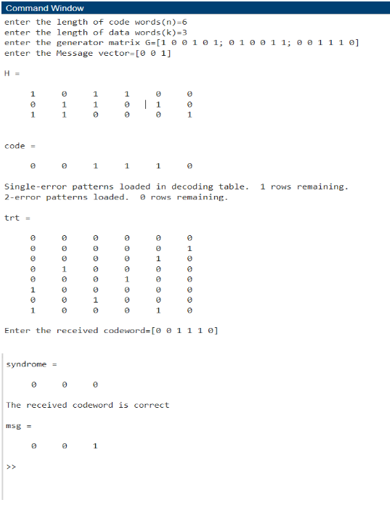
enter the length of code words(n)=6
enter the length of data words(k)=3
enter the generator matrix G=[1 0 0 1 0 1; 0 1 0 0 1 1; 0 0 1 1 1 0]
enter the Message vector=[0 0 1]
H =
1 0 1 1 0 0
0 1 1 0 1 0
1 1 0 0 0 1
code =
0 0 1 1 1 0
Single-error patterns loaded in decoding table. 1 rows remaining.
2-error patterns loaded. 0 rows remaining.
trt =
0 0 0 0 0 0
0 0 0 0 0 1
0 0 0 0 1 0
0 1 0 0 0 0
0 0 0 1 0 0
1 0 0 0 0 0
0 0 1 0 0 0
1 0 0 0 1 0
Enter the received codeword=[0 0 1 1 1 0]
syndrome =
0 0 0
The received codeword is correct
msg =
0 0 1
>>

